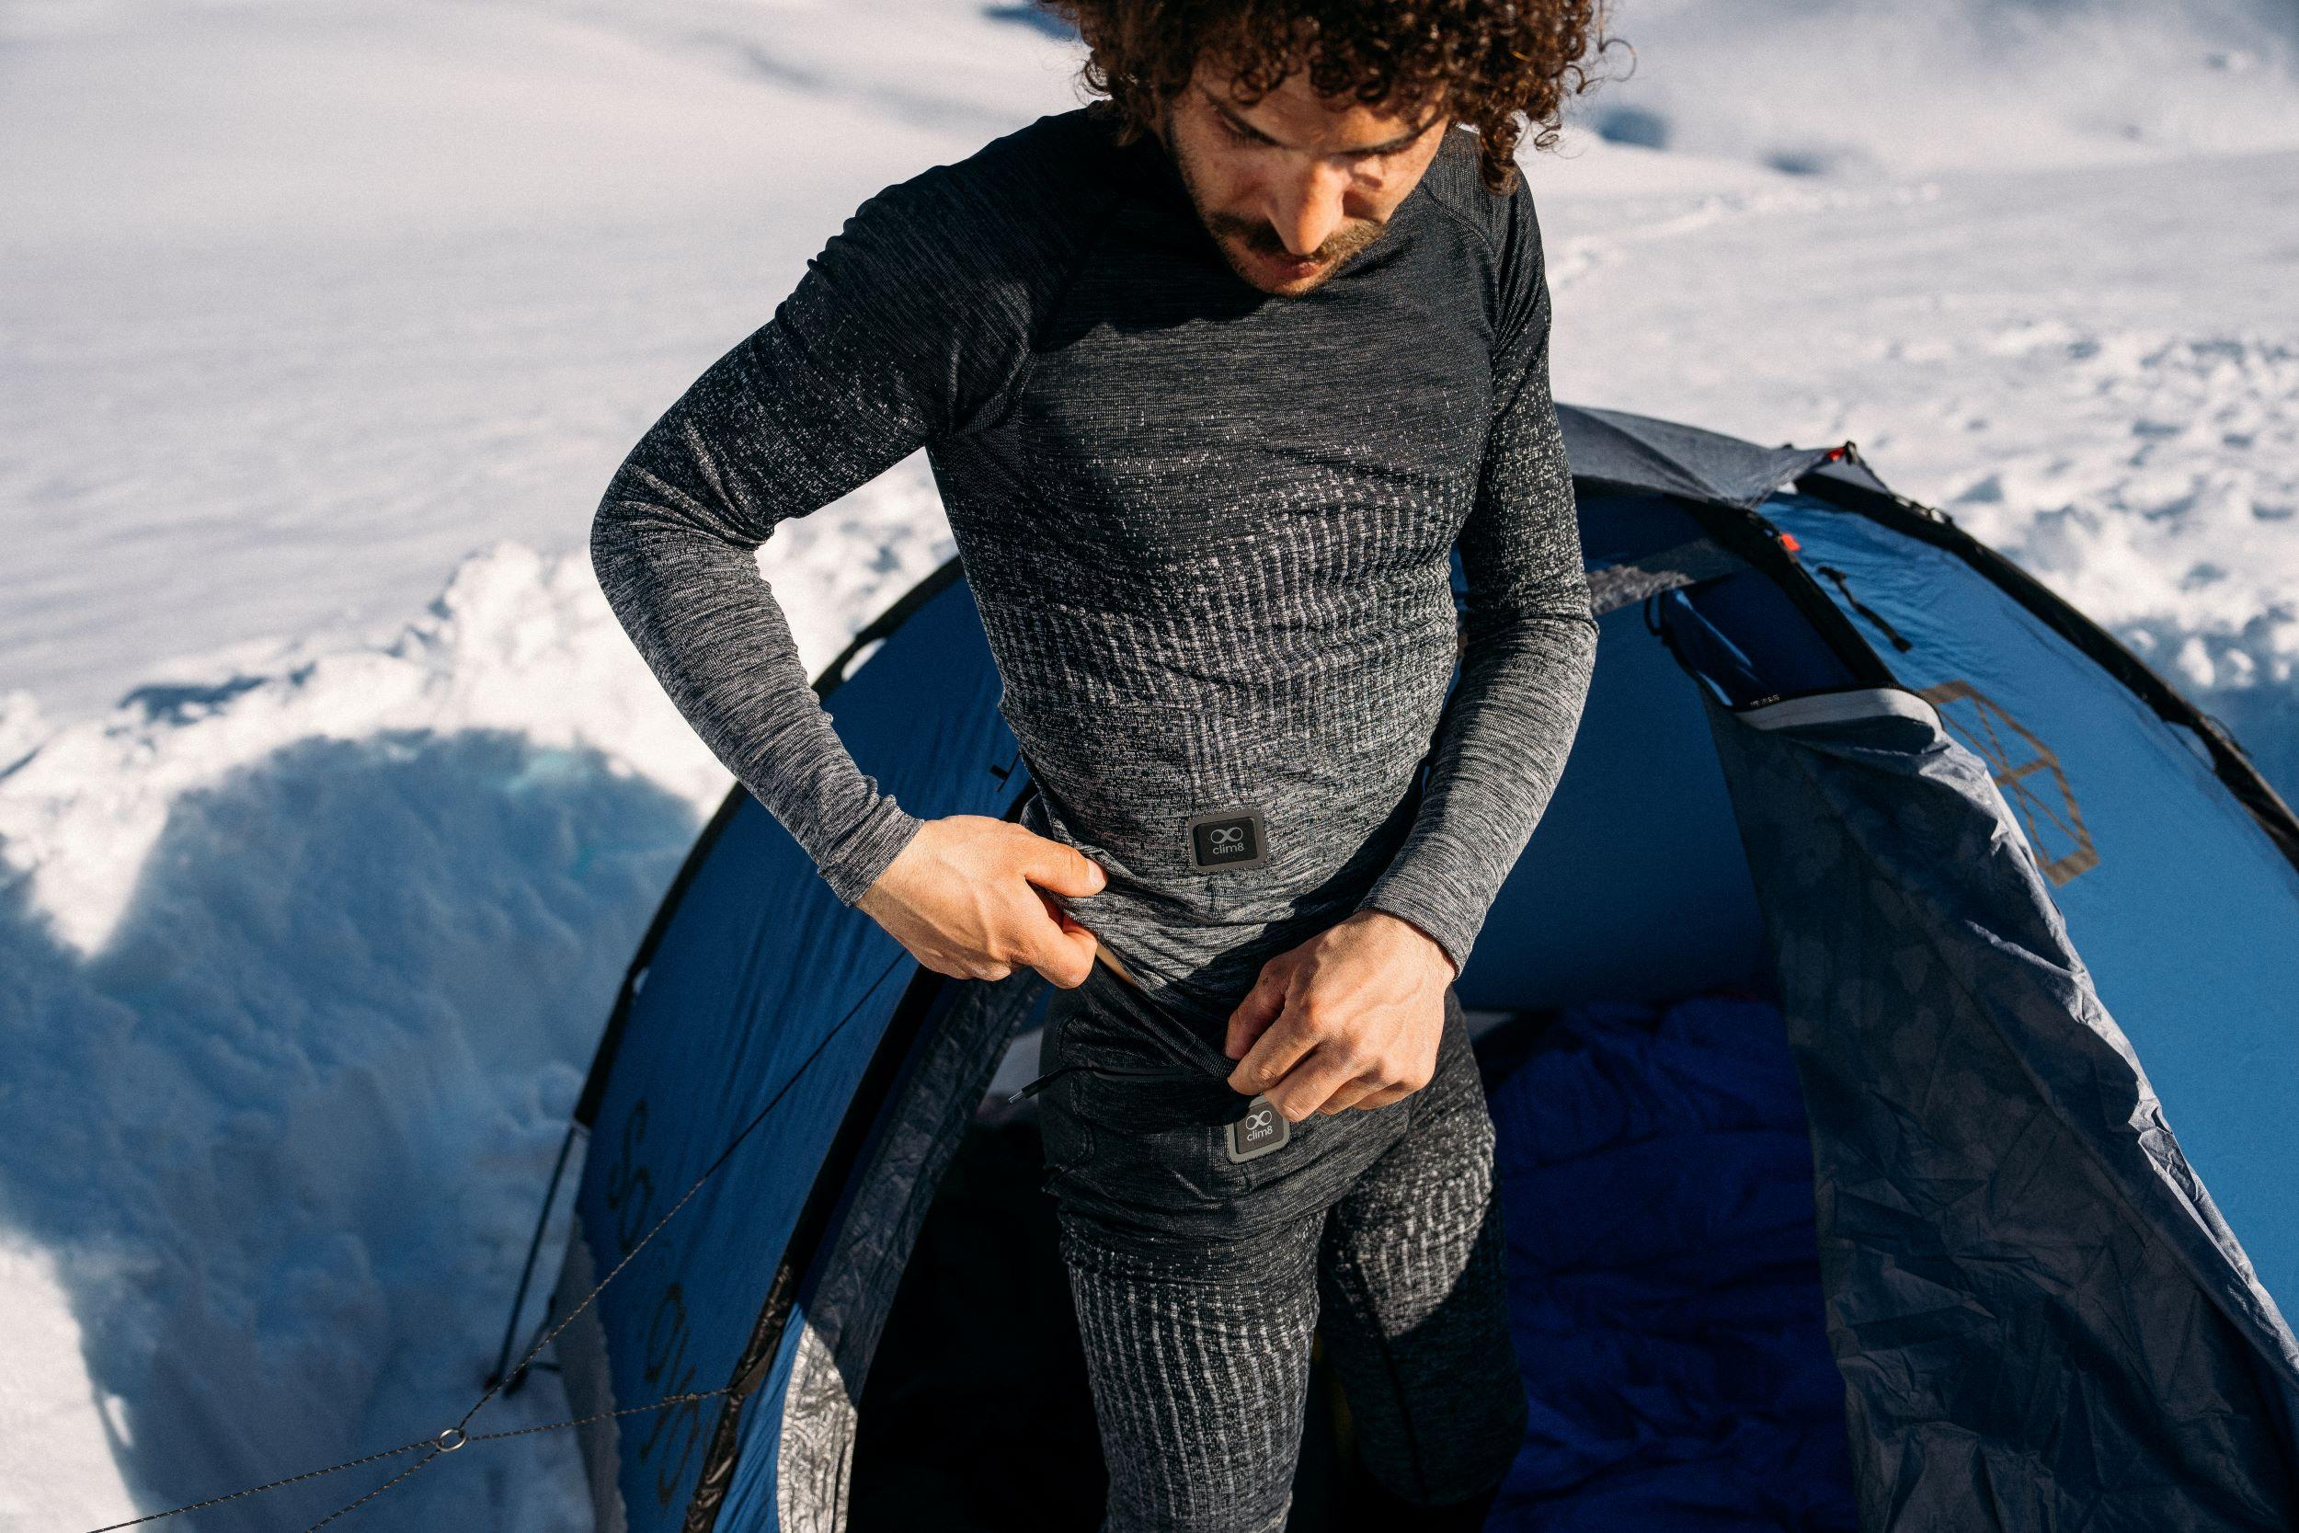**Odlo’s reimagined I-Thermic X-Warm collection elevates comfort for winter enthusiasts.**

***Seamlessly integrated Clim8® heating technology delivers warmth where it matters. An innovative design recognised with an ISPO industry award.***

**(Nov 26th, Hünenberg, CH**) – Inspired by its enduring passion for pushing boundaries, Odlo has fully redesigned its I-Thermic X-Warm collection to deliver a new level of comfort in cold-weather conditions.

The Swiss-based performance apparel brand has proudly collaborated with Clim8® to launch a range of apparel that seamlessly integrates smart heating technology to provide intelligent thermoregulation right at the wearer’s fingertips.

**Start Warm. Stay Warm.**

Purposefully designed for athletes that love getting out there during winter, the I-Thermic X-Warm 2.0 collection includes a seamless base layer set and outdoor jacket that intelligently warm areas of the body most sensitive to cold. Powered by a battery and a Bluetooth module, the integrated Clim8® heating system uses responsive sensors woven into the fabric in key thermal zones to maintain the desired body temperature.

Customised to the wearer’s exact preferences via a smartphone or by manually double-tapping the conveniently positioned control module. The system adapts in real time to the set profile, temperature and activity level. It also intelligently integrates user feedback to improve the experience over time and features body detection to automatically activate when the garment is put on.

Previously only available as a base layer, this redesign builds on its predecessor with a more streamlined fit, longer battery life and enhanced app integration, as well as expansion into a jacket style. On the practicality front, the garments are completely washable (once the battery is removed).

“The I-Thermic X-Warm combines Odlo’s renowned craftsmanship with integrated smart heating technology to deliver customisable warmth wherever and whenever it’s needed the most,” said Dan Pattison, Product Manager, Odlo. “We’re thrilled to heighten the outdoor experience with this collaborative innovation.”

The pieces are ideal for a wide spectrum of start-and-stop winter experiences - from the ski lift to lunch on the patio to après-ski – or as the perfect layer for additional warmth during long periods in cold temps.

**ISPO Award winning**

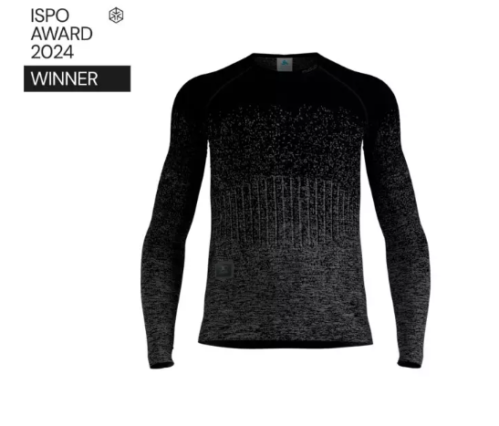Odlo, Clim8® and textile development partner Softmatter by MAS are thrilled that the I-Thermic X-Warm base layers have been recognised with a 2024 ISPO innovation award. This leading international sports platform honours the industry's most outstanding products and services.

The independent ISPO jury appreciated the seamless integration of the customisable and intuitive heating system, noting that the layers are ideal for a multitude of winter activities. The award will be presented at ISPO Munich on December 3rd, marking the seventh consecutive year that Odlo’s design innovation has been recognised at the world’s largest sports trade show.

Further information can be found [here](https://www.odlo.com/gb/en/i-thermic/).

**About Odlo**

**THERE’S MORE OUT THERE**

Inspired by Nordic sports and our founder's passion to push boundaries, [Odlo](http://www.odlo.com/) exists to heighten every outdoor experience. We design base layers without equal and all-season apparel that drives outdoor devotees to go for more, more often, in comfort.

We live for the limitless potential of personal podiums and shared experiences. And from the Swiss Alps, we develop clothing for those who know that whatever lies ahead – there’s always more out there.

**About Clim8**

Founded in France in 2016, [Clim8](https://myclim8.com/) develops the Clim8® smart heating technology, ensuring users stay comfortable and focused on their activity for longer. Integrated into clothing from premium partner brands, the technology embeds algorithms that analyse temperature, activity and user profile in real time for fully personalised heating, activated only when needed. All products are developed by a team of e-textile and thermophysiology experts in the Clim8® Lab, where durability and performance are tested under extreme conditions.

**About Softmatter by MAS**

[Softmatter by MAS](http://www.softmatter.io), a leader in textile innovation and electronics integration, is dedicated to transforming the landscape of functional apparel. Through collaborations with cutting-edge technology partners like Clim8 and renowned brands like Odlo, Softmatter by MAS is at the forefront of creating garments that elevate performance, recovery, and sustainability.

**About ISPO**

ISPO, the world’s largest sports trade show held annually in Munich, showcases the most innovative advancements in sportswear, apparel, and technology. Known for its dedication to excellence, ISPO connects the global sports community, bringing together industry leaders and innovators shaping the future of sports and activewear.

Kontakt zur Presse:

Outkomm public relations

Stefan Schiesser

Kesselbachstrasse 4, 9450 Altstätten

+41 78 757 17 05

[stefan.schiesser@outkomm.com](mailto:stefan.schiesser@outkomm.com)